Sycamore class Overview 2026-27
 | Autumn 1 |  | Autumn 2 |  | Spring 1 | Spring 2 |  | Summer 1 | Summer 2
Reading | When we were Warriors by Emma Carroll |  | Hansel and Gretel by Neil Gaiman and Lorenzo Mattotti |  | The Happy Prince and Other Tales by Oscar Wilde | The Explorer by Katherine Rundell |  | Great Adventures by Alistair Humphreys | Sky Chasers by Emma Carroll
Writing | 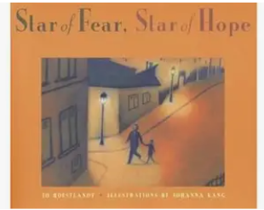 |  | 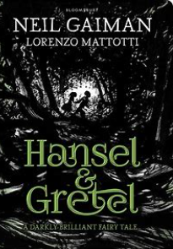 |  | 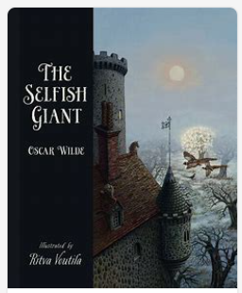 | 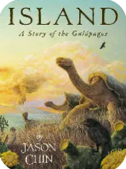 |  | 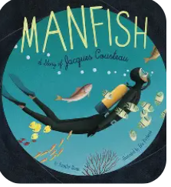 | 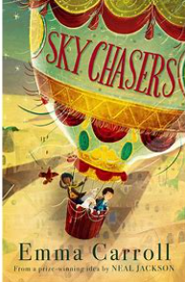
Maths | Number and Place Value  Start Addition and Subtraction  See First4Maths Planning |  | Multiplication and Division  Fractions  See First4Maths Planning |  | Decimals and Percentages  Ratio and Proportion  See First4Maths Planning | Algebra  Measure  See First4Maths Planning |  | Statistics  Geometry – shape- position - direction  See First4Maths Planning | Number- geometry – problem solving  See First4Maths Planning
Science | Living Things: Classifying Big and Small | Energy: Light and Reflection |  | Living Things: Evolution and Inheritance |  |  | Energy: Circuits, Batteries and Switches | Animals, including Humans: Circulation and Health | Making Connections: Are Some Sunglasses Safer than Others?
History/Geography | Why did the Romans invade and settle in Britain? |  | What are rivers and how are they used? |  | What is the legacy of the Ancient Greek Civilisation? | What is life like in the Alps? |  | Would you have preferred to live in the Stone Age/Bronze Age or Iron Age? | Why are rainforests important to us?
Art/DT | Drawing: Depth, Emotion and Movement:  Investigating: How can we express emotion movement and depth  Artist: Charlie MacKesy & Elizabeth Catlett |  | Textiles Bags |  | Paint/Mixed Media Portraits Artist: Frida Kahlo/Chila Burman (contrast Van Gogh) | Electrical Systems Steady Hand Game |  | Craft & Design: Architecture Artist: Friedensreich Hunderwasser, Zaha Hadid
RE | Why does religion look different around the world? (Kapow) |  | What do religious and non-religious world views believe about equality, justice and fairness? |  | Are Humanist and Christian ideas about science, conflicting or complementary? Does the Big Bang theory disprove the Genesis account on Creation? | How do Sikhs worship? |  | What are some of the differences and similarities within Christianity locally and globally? | What place does religion have in our world today?
PE | Invasion – Netball and Basketball- Mr B  QAA- Finding Success- EE |  | Athletics- Mr B  Dance- Materials- EE |  | Gymnastics- Mr B  Swimming - EE | Quidditch- Mr B  Swimming - EE |  | Athletics- Track and Field- Mr B  Cricket- EE | Striking and Fielding (Teamwork) – Mr B  Tennis – Net games for points- EE
Computing | Computing systems and networks: Bletchley Park and the history of computers |  | Computing systems and networks: Exploring AI |  | Data handling 1: Big Data 1 | Programming: Exploring Python |  | Data handling 2: Big Data 2 | Skills showcase: Inventing a product
Spanish | Unit 1 Describing family and friends in Spanish |  | Unit 1 Describing family and friends in Spanish |  | Unit 3 Sports in Spanish | Unit 4 Spanish food and drink |  | Unit 4 Spanish food and drink | Unit 6 In the Amazon Rainforest
Music | Future Yard |  | Future Yard |  | Future Yard | Future Yard |  | Future Yard | Future Yard
PSHE/RSE+H | My healthy self: How do my choices today shape my future wellbeing? |  | Connecting with Others: What does it mean to stand up for myself and others? |  | The Online World: How do I feel about being online? | Citizenship: How can we protect everyone’s rights? |  | Staying safe: How can I stay safe as I grow up? | Sex Education: How do people become parents and carers?
Visits/Visitors | KS2 Trip to Chester- Romans |  | KS2 Christmas Performance at church  Art Gallery Visit  Pantomime |  |  | Y6 Conway Residential

