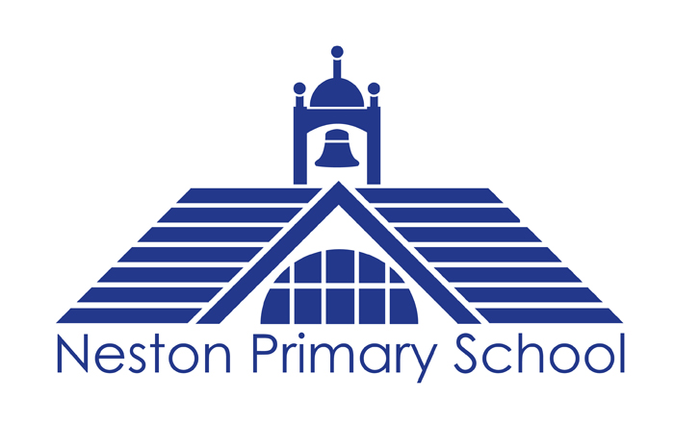

Spiritual, Moral,
Social and Cultural
(SMSC) Policy

Presented by: R Delap

Date presented: March 2021

Approved by Governors and Staff:

Review Date:

Signed ______________________________________
Chair of Governors/Vice Chair of Governors

Other relevant policies include; Safeguarding & Equality policies.

Rationale
At Neston Primary School Primary School, we commit to providing a learning experience which enables our pupils to develop a good self-awareness, healthy mind, a strong identity as a local and global citizens, and the critical thinking skills required to be able to contribute positively to their diverse and ever-changing world.
We believe that education should be holistic by placing the social, moral, spiritual and cultural development of our pupils, at the centre of our provision.
For these reasons, SMSC permeates through all our learning, rather than just as a stand alone subject, that is taught and threaded throughout our pupils’ school experience to ensure current and relevant issues are explored and strong links are made between the children’s own experiences and those of others.
Aims
Our SMSC provision aims to:
- Ensure that equality is at the core of all of our practices.
- Give our children the opportunity to explore SMSC themes in a critical thinking, relevant and empowering way.
- ● Teach the children about the power of their voice and the importance of this in shaping their world in a positive way.
- ● Ensure that pupil’s education is set within a context that is meaningful, and allows pupils to reflect upon their beliefs, feelings and responses to personal experience
- ● Enable pupils to develop an understanding of their individual and group identity
- ● Enable pupils to begin to develop an understanding of their social and cultural environment and an appreciation of the many cultures that now enrich our society along with their history.
- ● Give each pupil the opportunity to explore social and moral issues, and develop a sense of social and moral responsibility To promote ‘British Values’ in line with government guidance

Delivery & Content:
SMSC education is delivered at Neston Primary School through a variety of approaches:

PSHE lessons
- At Neston Primary School, we have carefully considered the subjects that impact greatly on our pupils’ lives and have developed a thematic approach to delivering SMSC lessons based on these subjects.
- Each theme has been planned to ensure progression throughout the school. Each theme is launched by individual class teachers and most themes use picture books to introduce subject matters in a child friendly, accessible way.
- Teachers then deliver lessons that explore the theme through critical enquiry and a ‘Philosophy for Children (P4C)’ approach.
- The themes covered within discrete lessons are:
- ● No Outsiders In Our School: Anti-bullying, celebrating difference & challenging prejudice & homophobia.
- ● People who inspire us: Stephen Hawking, Tim Peake/The two princes, Rosa Parks, Marie Curie. Malala Yousafzai, Martin Luther King Jr, David Attenborough
- ● UK & Diversity: Examining children’s perceptions of the UK, being British and who lives here.
- ● Equality: Embracing difference and ensuring fairness (all protected characteristics plus poverty)
- ● Drugs & Alcohol: Following the Christopher Winter scheme. ● Mental Health: My Happy Mind programme
- ● British/Human Values: Monarchy, political systems in the UK, democracy, rule of law, liberty and mutual respect for others’ beliefs.
- ● Knocking down stereotypes: Exploring gender stereotypes and the importance of being yourself.
- ● World’s Largest Lesson: Examining the Sustainable Development Goals ● More in Common: Exploring and challenging perceptions of Asylum Seekers, Refugees & Migrants.
- ● Financial responsibility
- ● Relationship and Sex Education (RSE): Following the Christopher Winter Scheme
- ● Promoting Diversity and challenging Homophobia: A range of Proud Trust promoted lessons based on age appropriate picture books.

Links to English
SMSC themes are explored through a broad range of texts studied during English
lessons. These texts are regularly changing but a critical thinking approach is applied in order to deepen children’s understanding of moral issues & dilemmas; cultural similarities & differences; environmental impacts; societal events & norms & spirituality.
As a school, we actively promote ‘writing for a real purpose’, encouraging each year group to produce an outcome piece that will make a change either on a societal basis or an environmental basis.

Rainbow Flag Award
Neston Primary School is a Rainbow Flag school (due to complete in 2022). The Rainbow Flag Award is a national quality assurance framework for primary schools, secondary schools, SEND schools and colleges. The award focuses on positive LGBT+, (lesbian, gay, bisexual, trans, plus other related identities), inclusion and visibility.
The Rainbow Flag Award encourages a whole organisation approach to LGBT+ inclusion, as well as developing strategies to effectively challenge and combat LGBTphobic bullying.
Our commitment to the Rainbow Flag Award is a commitment to improve the lives of all the young people that you work with, as well as the LGBT+ young people in your care, those from LGBT+ families, and LGBT+ staff members.
Religious Education lessons
Religious education lessons are taught weekly through a critical thinking lense which incorporates Philosophy for Children strategies, providing opportunities of open discussions in a safe environment. A range of world-faiths are studied from an objective perspective and the children understand that some people choose not to follow a faith at all.
Children are given time, space and information, that allows them to explore their own beliefs and those of other people.
Mindfulness & mental health
With an increasing awareness of the decline in children’s mental health, Neston Primary School has initiated a proactive approach to mental wellbeing by introducing mindfulness sessions for our children. We also ensure that we promote ways to improve mental health and maintain it both for children and all saff.
We also incorporate ‘My Happy Mind’ training within our SMSC lessons, which looks at the broader scale of emotions and strategies.
Learning Mentors
Our learning mentors work with children across the school – employing part of the ELSA programme and providing 121 support as and when it is required.
Our Learning Mentors work very closely with our safeguarding lead to ensure that children are monitored and supported as necessary.

PE
We are committed to a full PE provision at Neston Primary School, with opportunities to develop a wide range of skills.
RSE (Relationship & Sex Education)
At Neston Primary School school, we understand the importance of quality RSE and why starting this with young children is an important part of a process to create informed young adults capable of making choices regarding their sexual health and positive relationships.
The RSE programme reflects the school’s ethos and demonstrates and encourages the following values:
● Respect for self and others
● Inclusion
● Partnership
● Celebration of difference and diversity
School Council
Neston Primary School Primary School Council consists of 2 elected members from each class who work with the SMT and Governors in making positive changes in the school.
Education Committee
Each pair of representatives meet separately for tasks & feedback and then come together for a whole School Council meeting on a regular basis.
Recording of SMSC:
- SMSC planning
- Photos
- Wall displays
- Children’s work
- RE/SMSC books – individual and whole class
- Assembly book
Many aspects of SMSC that children explore go unrecorded but are evident in school ethos, pupil voice and informed conversations.

Leading, Monitoring and Evaluation:
Provision for SMSC is led, monitored and reviewed continually. Monitoring takes place through:
● Lesson feedback
● Learning walks
● Pupil voice questionnaires/meetings
● School environment
● Staff feedback
SMSC is evaluated, reviewed and adapted on a regular basis to ensure it is still relevant and valuable to our learners.

