‘The Buzz’

**What’s been happening at NPS?**

**November 2022**

This half term feels as though it is flying by. Thank you so much for your generosity with Children in Need, Stuff the Sleigh and the donations that have started to come in for the Christmas fair. 

**Y6 Visit to the Crucial Crew**

Y6’s annual Crucial Crew visit was a success again this year. The children learnt about different ways to keep safe throughout the day.

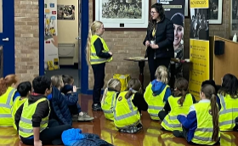



**FS and Y1 Inside the Igloo Dance Show**

The children in F1, F2 and Y1 enjoyed watching theInside the Igloo dance show last week and then F2 and Y1 had a wonderful workshop to develop their own dancing skills.

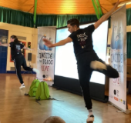 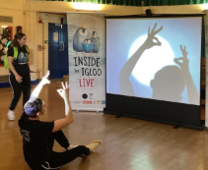 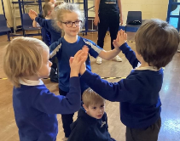



It has been assessment week this week and in my meetings with teachers, it has been wonderful to discuss the progress being made in every class.

**Rotakids at Neston High School.**

A group of our Y6 Rotakids went to the high school with Mrs Muskett to inform them of everything Rotakids do and hopefully encourage the high school students to join in. Mrs Muskett said they all spoke confidently and clearly in front of the audience.

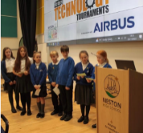

**Y1 and Y2 Author Visit**

Y1 and Y2 were lucky to have Christine Field-Davies come and read her latest book ‘Yes! Even a Mouse’. She has also donated a copy to each class to keep in their book corners.

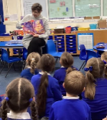 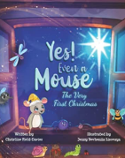



**Y4 Let’s Walk**

The children in Y4 all passed their Let’s Walk training with the local PCSOs and were awarded their certificates in assembly this week.

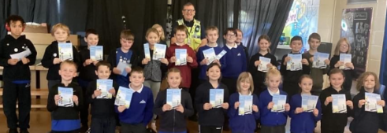



**Y5 Christmas Experience**

Y5 represented the school brilliantly when they visited St Michael’s Church to learn more about the Christmas story.



Christmas Fair FRIDAY 9th DECEMBER

Thank you to the small group of parents who have helped organise events for the Christmas Fair. Staff will be on the stalls on day. We would be grateful for any help on Monday and Tuesday next week to sort items and prizes and also help during the afternoon on Friday to set up the stalls.

**Whole school Homework**

I have been so impressed with the Christmas Pots that have been brought into school. Mrs Lea (governor) has had the hard job of choosing a winner from each class. All winners will be shared on Facebook over the weekend.

ATTENDANCE

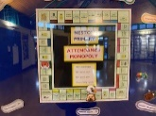

Attendance has suffered this month with the increase in illnesses around school. Our November attendance was 91%, 5% less than September and October and our target figure of 96%.

**UPCOMING DIARY DATES:**

**December**

5th Y3 Christmas Experience at the Methodist Church

6th Whole School Reindeer Run

7th Last day for Stuff the Sleigh donations

9th & 12th KS2 Christmas rehearsal at Parish Church

**9th Christmas Fair 3:30-5pm**

**12th KS1 Nativity Performance for Parents 2pm**

**13th KS2 Carol Service (Parish Church) for Parents 10am**

**13th KS1 Nativity Performance for Parents 2pm**

**15th Christmas Dinner and Parties (own clothes)**

**16th Last Day of term – closes at 3:15pm**